

Semester Two Examination, 2021

Question/Answer booklet

MATHEMATICS  
APPLICATIONS  
UNITS 3&4

**SOLUTIONS**

Section One:  
Calculator-free

|  |  |  |  |  |  |  |  |  |  |  |
| --- | --- | --- | --- | --- | --- | --- | --- | --- | --- | --- |
| WA student number: In figures |  |  |  |  |  |  |  |  |  |  |

In words

Your name

|  |  |
| --- | --- |
| Number of additional answer booklets used (if applicable): |  |

## Time allowed for this section

Reading time before commencing work: five minutes

Working time: fifty minutes

## Materials required/recommended for this section

***To be provided by the supervisor***

This Question/Answer booklet

Formula sheet

***To be provided by the candidate***

Standard items: pens (blue/black preferred), pencils (including coloured), sharpener,  
correction fluid/tape, eraser, ruler, highlighters

Special items: nil

## Important note to candidates

No other items may be taken into the examination room. It is **your** responsibility to ensure that you do not have any unauthorised material. If you have any unauthorised material with you, hand it to the supervisor **before** reading any further.

## Structure of this paper

|  |  |  |  |  |  |
| --- | --- | --- | --- | --- | --- |
| Section | Number of questions available | Number of questions to be answered | Working time (minutes) | Marks available | Percentage of examination |
| Section One: Calculator-free | 8 | 8 | 50 | 52 | 35 |
| Section Two: Calculator-assumed | 13 | 13 | 100 | 98 | 65 |
|  | | |  | **Total** | 100 |

## Instructions to candidates

1. The rules for the conduct of examinations are detailed in the school handbook. Sitting this examination implies that you agree to abide by these rules.

2. Write your answers in this Question/Answer booklet preferably using a blue/black pen.  
Do not use erasable or gel pens.

3. You must be careful to confine your answers to the specific question asked and to follow any instructions that are specific to a particular question.

4. Show all your working clearly. Your working should be in sufficient detail to allow your answers to be checked readily and for marks to be awarded for reasoning. Incorrect answers given without supporting reasoning cannot be allocated any marks. For any question or part question worth more than two marks, valid working or justification is required to receive full marks. If you repeat any question, ensure that you cancel the answer you do not wish to have marked.

5. It is recommended that you do not use pencil, except in diagrams.

6. Supplementary pages for planning/continuing your answers to questions are provided at the end of this Question/Answer booklet. If you use these pages to continue an answer, indicate at the original answer where the answer is continued, i.e. give the page number.

7. The Formula sheet is not to be handed in with your Question/Answer booklet.

Section One: Calculator-free 35% (52 Marks)

This section has**eight** questions. Answer **all** questions. Write your answers in the spaces provided.

Working time: 50 minutes.

Question 1 (5 marks)

A sequence is defined as $T_{n+1}=T_{n}+a$ with $T_{1}=b$, so that $T_{4}=40$ and $T_{5}=43$.

(a) Determine the value of the constant $a$ and the value of the constant $b$. (2 marks)

|  |
| --- |
| Solution |
| $$a=43-40=3$$ $40-3-3-3=31$ and so $b=31$. |
| Specific behaviours |
| ✓ value of $a$ ü value of $b$ |

The sequence can also be written in the form $T_{n}=an+k$.

(b) Determine the value of the constant $k$. (1 mark)

|  |
| --- |
| Solution |
| $$T_{n}=31+\left(n-1\right)\left(3\right) \\ =31+3n-3 \\ =3n+28$$ Hence $k=28$. |
| Specific behaviours |
| ✓ value of $k$ |

(c) Determine the value of $n$ so that $T_{n}=250$. (2 marks)

|  |
| --- |
| Solution |
| $$3n+28=250 \\ 3n=222 \\ n=74$$ |
| Specific behaviours |
| ✓ forms equation and simplifies  ü value of $n$ |

Question 2 (6 marks)

(a) A connected planar graph has $14$ vertices and $9$ faces. Determine the number of edges this graph has. (2 marks)

|  |
| --- |
| Solution |
| Using Euler's formula $14+9-e=2⇒e=21$ Hence graph has $21$ edges. |
| Specific behaviours |
| ✓ correct use of Euler's formula  ü correct number of edges |

(b) The vertices in the following graph can be split into two distinct groups to demonstrate that the graph is bipartite. List the vertices in each group. (2 marks)

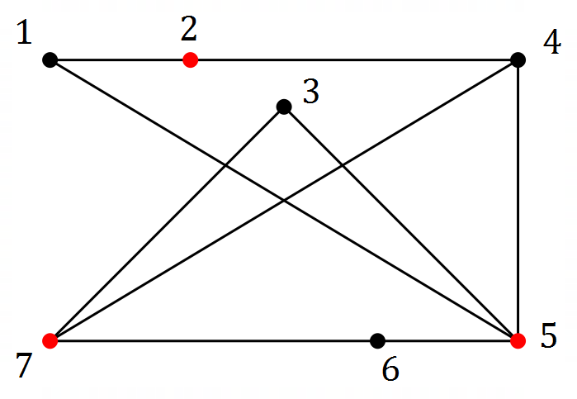

|  |
| --- |
| Solution |
| Groups are $\{1, 3, 4, 6\}$ and $\{2, 5, 7\}$ |
| Specific behaviours |
| ✓ marks alternate vertices/redraws  ü correctly lists groups |

(c) Determine the number of edges that must be removed from a complete graph with $5$ vertices so that it becomes a tree with $5$ vertices. (2 marks)

|  |
| --- |
| Solution |
| $K_{5}$ has $5×4÷2=10$ edges.  Tree with $5$ vertices has $4$ edges.  Hence remove $10-4=6$ edges. |
| Specific behaviours |
| ✓ edges in $K_{5}$ ü correct number to remove |

Question 3 (7 marks)

A company runs sightseeing boat trips from several terminals throughout a harbour city. In the graph below, the numbered vertices represent terminals, and the edges represent trips either between the terminals or that start and finish at the same terminal.

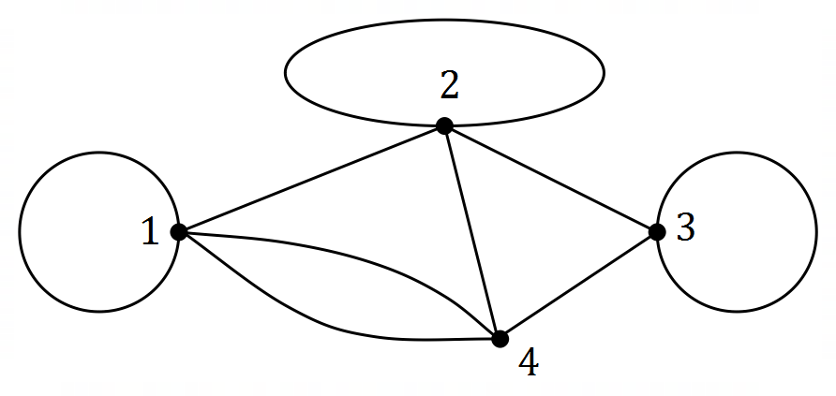

(a) State two reasons why the graph above is not simple. (2 marks)

|  |
| --- |
| Solution |
| The graph has loops and multiple edges. |
| Specific behaviours |
| ✓ states loops  ü states multiple edges |

(b) Construct an adjacency matrix from the graph. (2 marks)

|  |
| --- |
| Solution |
| $$\left[\begin{matrix}1 & 1 & 0 & 2 \\ 1 & 1 & 1 & 1 \\ 0 & 1 & 1 & 1 \\ 2 & 1 & 1 & 0\end{matrix}\right]$$ |
| Specific behaviours |
| ✓ symmetrical matrix  ü correct adjacency matrix |

(c) Describe two conditions necessary for the existence of a semi-Eulerian trail in a graph and state the length of such a trail in the above graph. (3 marks)

|  |
| --- |
| Solution |
| The graph must (i) be connected; and  (ii) have exactly two odd vertices  Length of trail is $9$ edges. |
| Specific behaviours |
| ✓ one condition for semi-Eulerian trail  ü second condition for semi-Eulerian trail  ü length of trail |

Question 4 (10 marks)

An analyst collected data from a sample of ten trees in a plantation, as shown in the table below.

The variables $x$ and $y$ are the diameter of a tree in centimetres and the daily water use of the tree in litres respectively.

$\hat{y}$ is the predicted daily water use in litres, calculated using the least-squares line $\hat{y}=2.2x+0.6$, and $R$ is the residual.

|  |  |  |  |  |  |  |  |  |  |  |
| --- | --- | --- | --- | --- | --- | --- | --- | --- | --- | --- |
| $$x$$ | $$12$$ | $$15$$ | $$20$$ | $$22$$ | $$24$$ | $$27$$ | $$31$$ | $$35$$ | $$39$$ | $$43$$ |
| $$y$$ | $$32.5$$ | $$35$$ | $$41.5$$ | $$48.5$$ | $$52.5$$ | $$56.5$$ | $$66$$ | $$77$$ | $$90$$ | $$98.5$$ |
| $$\hat{y}$$ | $$27$$ | $$33.6$$ | - | $$49$$ | $$53.4$$ | $$60$$ | $$68.8$$ | $$77.6$$ | $$86.4$$ | $$95.2$$ |
| $$R$$ | $$5.5$$ | $$1.4$$ | - | $$-0.5$$ | $$-0.9$$ | $$-3.5$$ | $$-2.8$$ | $$-0.6$$ | - | $$3.3$$ |

Nine of the data points $(x, y)$ are shown on this scatterplot:

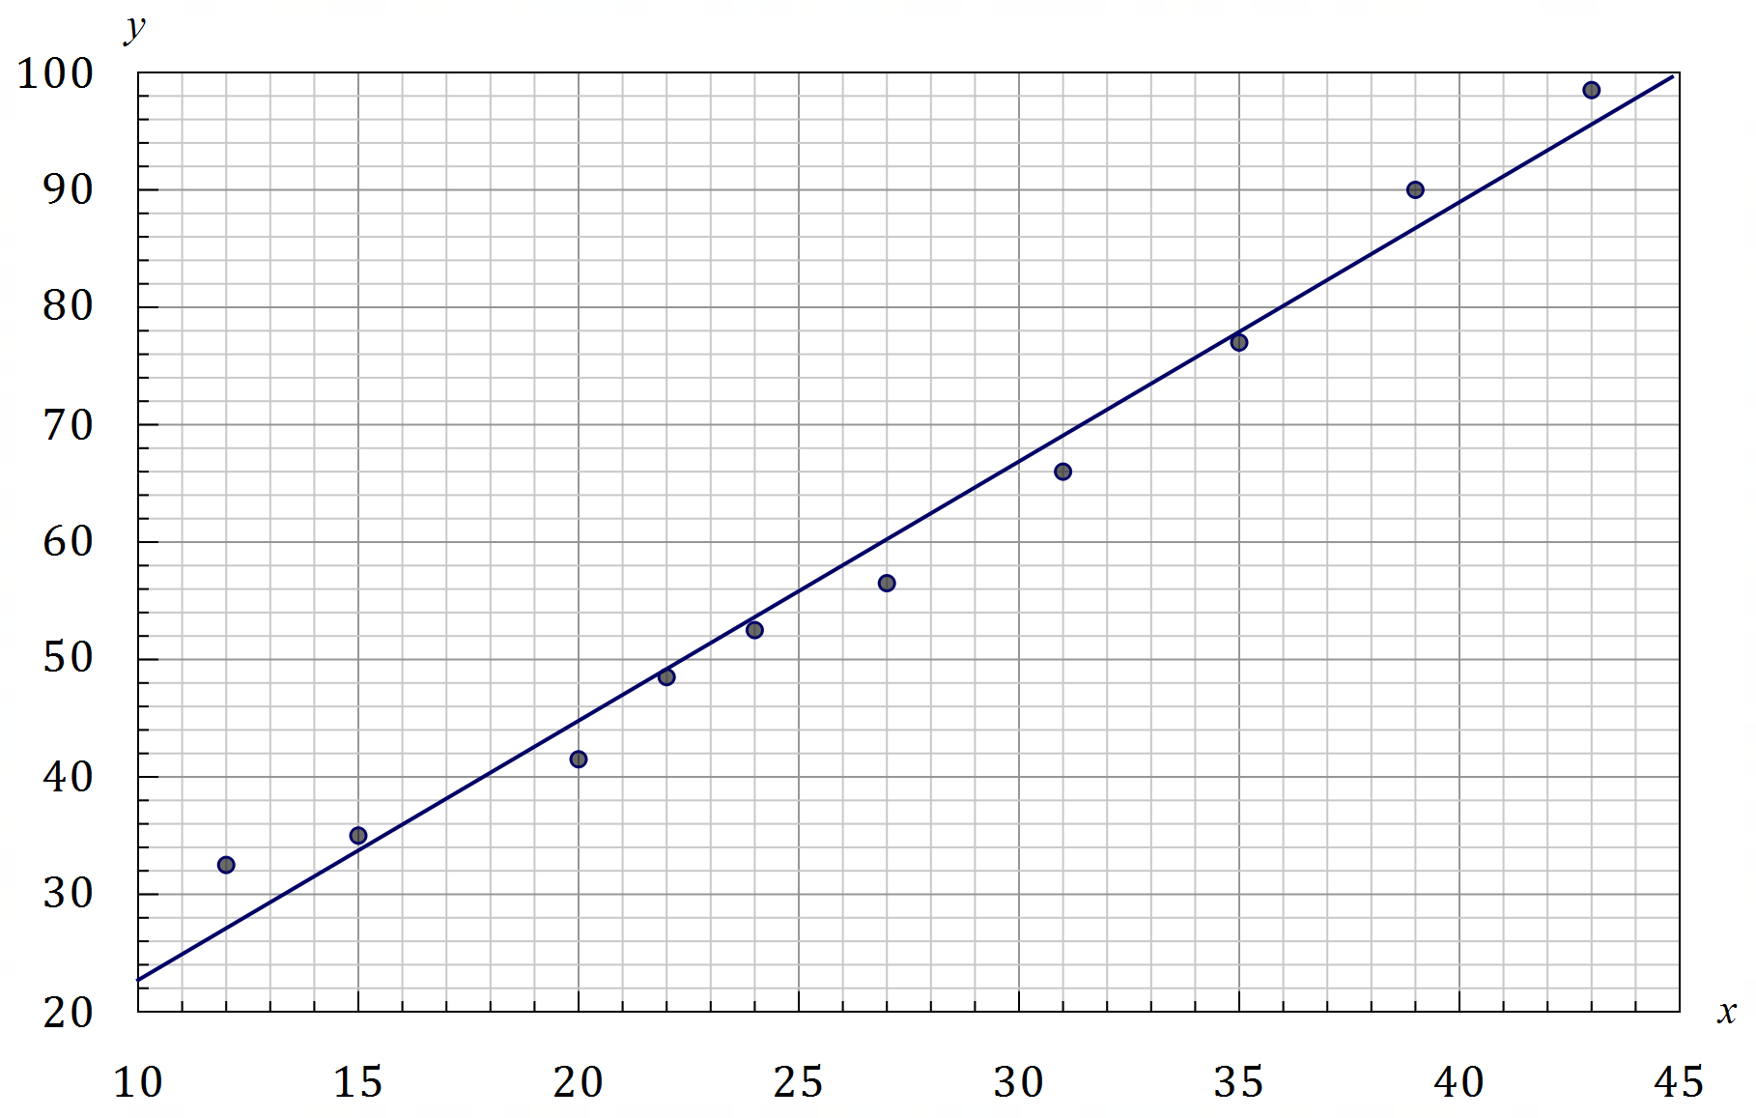

|  |
| --- |
| Solution |
| See graph: $(31, 66)$ |
| Specific behaviours |
| ✓ correctly plots point |

(a) Add the missing point to the scatterplot. (1 mark)

(b) Explain how information from the table can be used to draw the least-squares line on the scatterplot and hence draw this line. (2 marks)

|  |
| --- |
| Solution |
| Plot at least two points using $(x, \hat{y})$ and draw line through these points. |
| Specific behaviours |
| ✓ explains use of $(x, \hat{y})$ ü correct line on graph |

(c) Determine the value of the residual $R$ when:

|  |
| --- |
| Solution |
| $$R=90-86.4=3.6$$ |
| Specific behaviours |
| ✓ correct residual |

(i) $x=39$. (1 mark)

(ii) $x=20$. (2 marks)

|  |
| --- |
| Solution |
| $$\hat{y}=2.2\left(20\right)+0.6=44.6$$ $$R=41.5-44.6=-3.1$$ |
| Specific behaviours |
| ✓ calculates  ✓ correct residual |

(d) Construct a residual plot on the axes below. (2 marks)

|  |
| --- |
| Solution |
| See graph |
| Specific behaviours |
| ✓ at least $7$ correct points  ü all points correct, no lines |

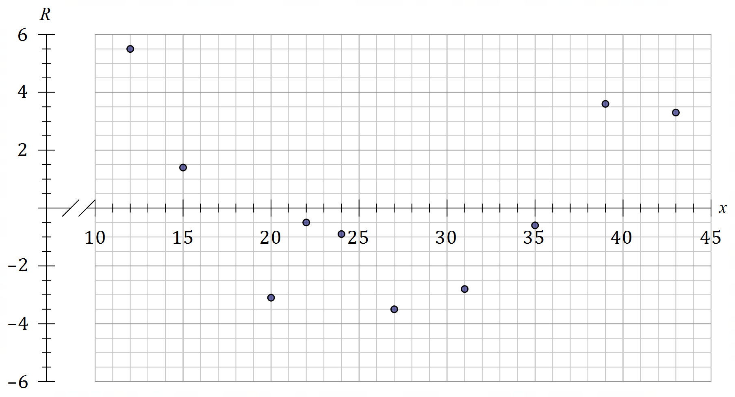

(e) Comment on the appropriateness of fitting a linear model to the data. Justify your answer.

(2 marks)

|  |
| --- |
| Solution |
| A linear model is not appropriate as a clear pattern is evident in the residual plot. |
| Specific behaviours |
| ✓ states not appropriate  ü refers to pattern evident in residual plot |

Question 5 (5 marks)

|  |  |  |  |  |
| --- | --- | --- | --- | --- |
|  | Section | | | |
|  | $$1$$ | $$2$$ | $$3$$ | $$4$$ |
| Drew | $$33$$ | $$26$$ | $$32$$ | $$34$$ |
| Eve | $$27$$ | $$26$$ | $$29$$ | $$28$$ |
| Faye | $$30$$ | $$27$$ | $$30$$ | $$32$$ |
| Gem | $$31$$ | $$30$$ | $$27$$ | $$30$$ |

A relay team consists of four cadets  
who must each be assigned to one of  
the four sections of an assault course  
in order to minimise their overall time.

The table shows the least time, in  
minutes, that each cadet has  
previously taken to complete  
the different sections.

(a) Show use of the Hungarian algorithm to determine the optimum assignment of cadets, writing the assignment in the table below. (4 marks)

|  |
| --- |
| Solution (columns first) |
| Reduce columns $$\left[\begin{matrix}6 & 0 & 5 & 6 \\ 0 & 0 & 2 & 0 \\ 3 & 1 & 3 & 4 \\ 4 & 4 & 0 & 2\end{matrix}\right]$$ Reduce rows and cover zeros $$\left[\begin{matrix}6 & 0 & 5 & 6 \\ 0 & 0 & 2 & 0 \\ 2 & 0 & 2 & 3 \\ 4 & 4 & 0 & 2\end{matrix}\right]$$ Use algorithm $(±2)$ $$\left[\begin{matrix}4 & 0 & 3 & 4 \\ 0 & 2 & 2 & 0 \\ 0 & 0 & 0 & 1 \\ 4 & 6 & 0 & 2\end{matrix}\right]$$ |
| Specific behaviours |
| ✓ reduce rows and columns  ü cover zeros with $3$ lines  ü apply algorithm  ü correct assignment |

|  |
| --- |
| Solution (rows first) |
| Reduce rows $$\left[\begin{matrix}7 & 0 & 6 & 8 \\ 1 & 0 & 3 & 2 \\ 3 & 0 & 3 & 5 \\ 4 & 3 & 0 & 3\end{matrix}\right]$$ Reduce columns and cover zeros $$\left[\begin{matrix}6 & 0 & 6 & 6 \\ 0 & 0 & 3 & 0 \\ 2 & 0 & 3 & 3 \\ 3 & 3 & 0 & 1\end{matrix}\right]$$ Use algorithm $(±2)$ $$\left[\begin{matrix}4 & 0 & 4 & 4 \\ 0 & 2 & 3 & 0 \\ 0 & 0 & 1 & 1 \\ 3 & 5 & 0 & 1\end{matrix}\right]$$ |
| Specific behaviours |
| ✓ reduce rows and columns  ü cover zeros with $3$ lines  ü apply algorithm  ü correct assignment |

|  |  |  |  |  |
| --- | --- | --- | --- | --- |
| Section | $$1$$ | $$2$$ | $$3$$ | $$4$$ |
| Cadet | **Faye** | **Drew** | **Gem** | **Eve** |

(b) State the least overall time for the team to complete the relay. (1 mark)

|  |
| --- |
| Solution |
| Time is $30+26+27+28=111$ minutes. |
| Specific behaviours |
| ✓ correct time |

Question 6 (7 marks)

The edge weights on the graph below represent the time, in milliseconds, to send a data packet between routers on a computer network, represented by the vertices.

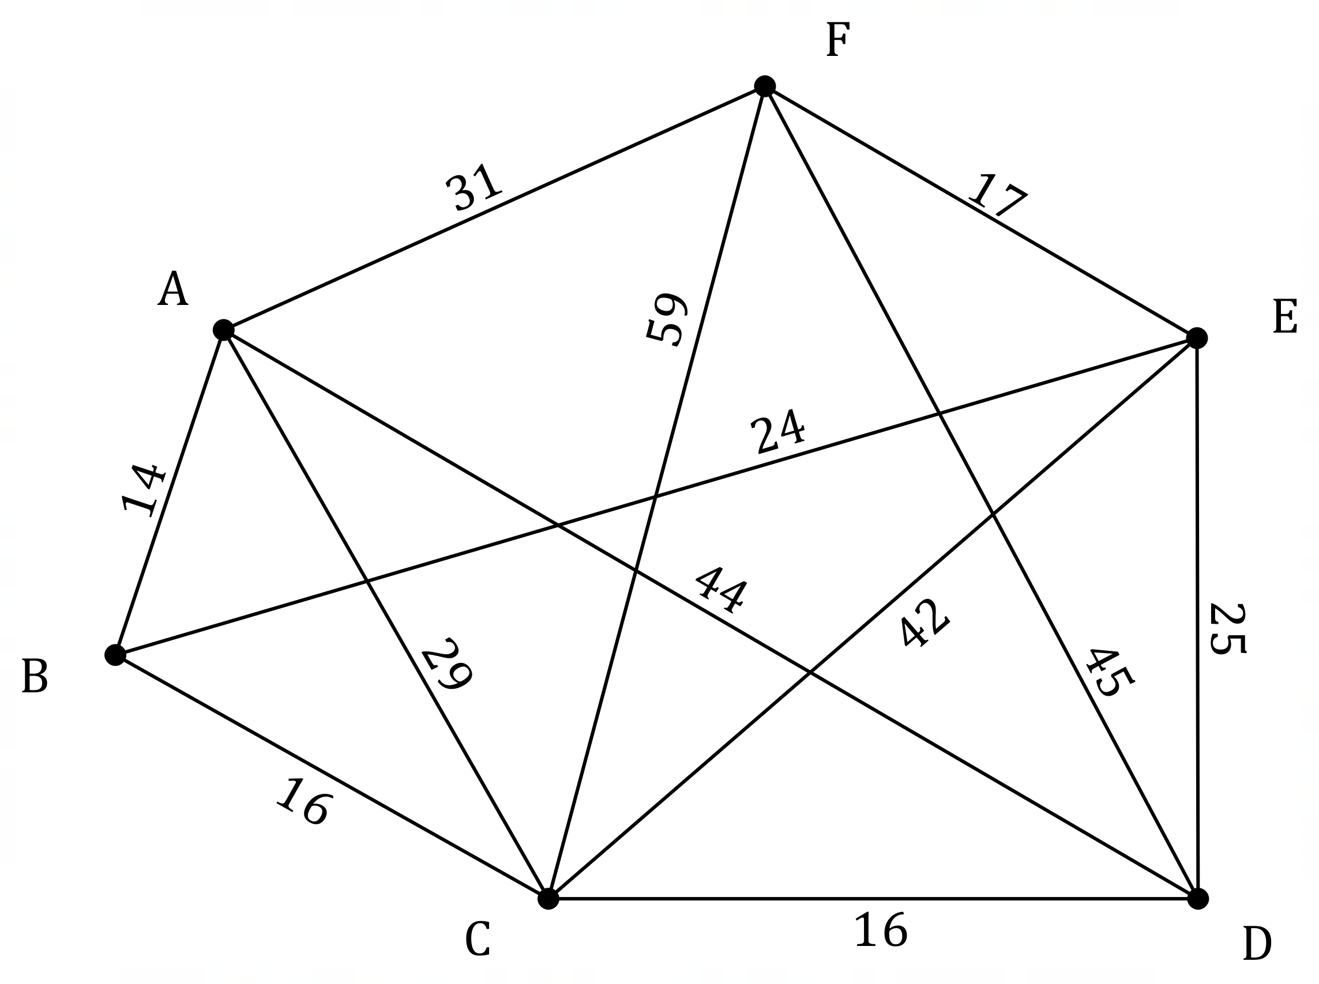

(a) Determine the minimum time to send a data packet from router $C$ to router $F$ and state, in order, the routers on this path. (3 marks)

|  |
| --- |
| Solution |
| Routers on path: $CBEF$ Minimum time: $16+24+17=57$ milliseconds. |
| Specific behaviours |
| ✓ evidence of checking times for at least two paths  ü correct path  ü correct minimum time |

(b) Explain, with justification, why the graph in this question is Hamiltonian. (2 marks)

|  |
| --- |
| Solution |
| The graph contains a cycle that visits all vertices. For example, the cycle $ABCDEFA$. |
| Specific behaviours |
| ✓ explanation using **cycle** and **all vertices**  ü example of Hamiltonian cycle in graph |

(c) State, with reasoning, the least number of edges that must be removed from the graph so that it is no longer Hamiltonian. (2 marks)

|  |
| --- |
| Solution |
| $2$ edges. By removing any $2$ of the $3$ edges from vertex $B$ the graph will become semi-Hamiltonian. |
| Specific behaviours |
| ✓ correct number  ü reasoning |

Question 7 (6 marks)

A clinic recorded the number of cases of influenza that presented each quarter, and an extract from the data is shown in the table and graph below.

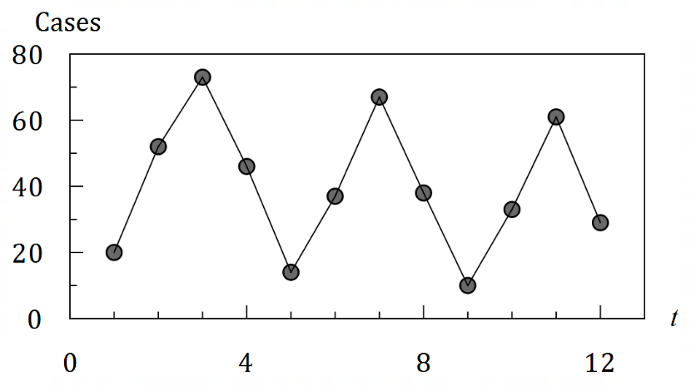

|  |  |  |  |  |
| --- | --- | --- | --- | --- |
|  | Cases per quarter | | | |
| Year | $$1$$ | $$2$$ | $$3$$ | $$4$$ |
| $$2016$$ | $$20$$ | $$52$$ | $$73$$ | $$46$$ |
| $$2017$$ | $$14$$ | $$37$$ | $$67$$ | $$38$$ |
| $$2018$$ | $$10$$ | $$33$$ | $$61$$ | $$29$$ |

(a) Describe the trend and seasonality of the data. (2 marks)

|  |
| --- |
| Solution |
| There is a decreasing/downward trend.  Cases are highest in the third quarter and lowest in the first quarter of each year. |
| Specific behaviours |
| ✓ indicates direction of trend  ü indicates features common to all years |

(b) Calculate the $4$-point centred moving average for the number of cases that presented in the third quarter of $2016$. (2 marks)

|  |
| --- |
| Solution |
| $$\frac{20}{2}+52+73+46+\frac{14}{2}=188 \\ \frac{188}{4}=47$$ Moving average is $47$ cases. |
| Specific behaviours |
| ✓ indicates correct method  ü correct moving average |

The $3$-point moving average for the number of cases that presented in the fourth quarter of $2018$ is $34$.

(c) Determine the number of cases that presented in the first quarter of $2019$. (2 marks)

|  |
| --- |
| Solution |
| $$\frac{61+29+x}{3}=34 \\ 90+x=102 \\ x=12$$ Hence $12$ cases presented that quarter. |
| Specific behaviours |
| ✓ indicates correct equation  ü correct number of cases |

Question 8 (6 marks)

The network below represents the durations and interdependencies of the $11$ activities required to complete a project. For example, activity $M$ has a duration of $9$ days and cannot commence until activities F and L are complete.

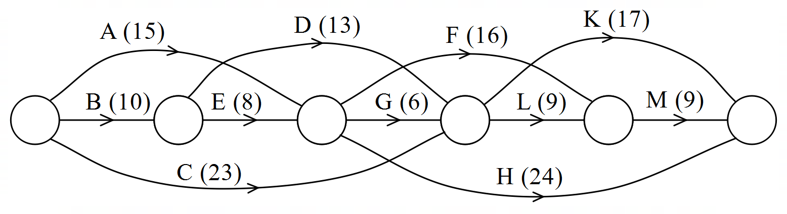

(a) Determine the minimum completion time for the project. (2 marks)

|  |
| --- |
| Solution |
| Earliest start times $$A,B,C=0; D,E=10; F,G,H=18; K,L=24; M=34; \text{End}=43.$$ Minimum completion time is $43$ days. |
| Specific behaviours |
| ✓ evidence of EST's  ü correct minimum completion time |

(b) Determine which of the non-critical activities has the greatest float time and state the earliest start time and latest start time for this activity. (2 marks)

|  |
| --- |
| Solution |
| Activity $A$. It has EST: day $0$ and LST: day $3$. |
| Specific behaviours |
| ✓ states activity  ü states EST and LST |

(c) Proposed changes to the project will halve the duration of activity E. Determine the impact this will have on the critical path of the project and its minimum completion time. (2 marks)

|  |
| --- |
| Solution |
| The critical path will change and there will be two of them. ( $BDLM$ and $CLM$).  Minimum completion time will decrease by $2$ days (to $41$ days). |
| Specific behaviours |
| ✓ states critical path changes and indicates there will be two  ü states change in MCT or new MCT |

Supplementary page

Question number: _________

Supplementary page

Question number: _________

Supplementary page

Question number: _________

Supplementary page

Question number: _________

© 2021 WA Exam Papers. Kennedy Baptist College has a non-exclusive licence to copy and communicate this document for non-commercial, educational use within the school. No other copying, communication or use is permitted without the express written permission of WA Exam Papers. SN245-186-3.